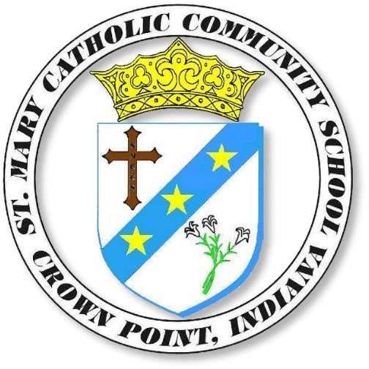

St. Mary Catholic Community School 405 East Joliet Street, Crown Point

Substitute Teachers Needed
Our class sizes are small, our students are well-behaved, and the staff are very supportive. Those
interested in subbing at St. Mary’s should contact Mrs. Angelina McDonald at 663-0676 or email amcdonald@stmarycp.org with “Substitute Teacher” in the subject line. The pay is competitive, and you might just be surprised how rewarding it can be to spend the day with an awesome group of youngsters at St. Mary’s!



