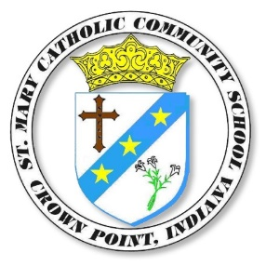
Saint Mary Catholic Community School, Crown Point, IN
Job Posting: Grade 3 Instructional Aide

Title /Position: | Instructional Aide
Date Close: | Tuesday, August 4, 2026
Hours: | 6:55 AM to 11:30 AM (2 or 3 day per week rotation)
Start Date: | Monday, August 10, 2026
Job Description
St. Mary’s is looking for an Instructional Aide under lead teacher, Mrs. Mirabel Villarreal.
St. Mary Catholic Community School is seeking an individual to assist the classroom teacher in daily activities, grading, and instruction. Candidates should be competent with technology. This position provides the opportunity to work with a highly motivated, dedicated, and creative team of colleagues in a top-rated parochial school.
Job Qualifications
Minimum requirements: high school diploma.
Degree or college hours are a plus.
Contact Information
Name: | Tom Ruiz
Application Instructions
Submit letter of interest and resume with references to: truiz@stmarycp.org with only the words “Grade 3 AIDE” in the subject line.

